2 – Introduction to Java

Java is an object-oriented, class-based, secured and general-purpose computer-programming language. It is a widely used robust technology.
#NOTE - Robust programming is a style of programming that focuses on handling unexpected termination and unexpected actions.

What is Java?
Java is a programming language and a platform. Java is a high level, robust, object-oriented and secure programming language.
Java was developed by Sun Microsystems (which is now the subsidiary of Oracle) in the year 1995. James Gosling is known as the father of Java. Before Java, its name was Oak. Since Oak was already a registered company, so James Gosling and his team changed the name from Oak to Java.
Platform: Any hardware or software environment in which a program runs, is known as a platform. Since Java has a runtime environment (JRE) and API, it is called a platform.

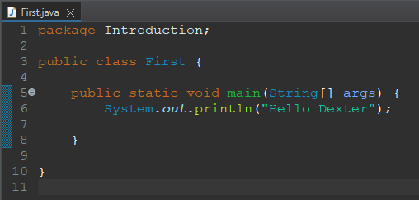
Java Example
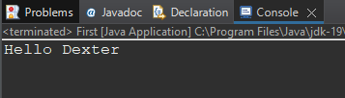

Application
According to Sun, 3 billion devices run Java. There are many devices where Java is currently used. Some of them are as follows:
- Desktop Applications such as acrobat reader, media player, antivirus, etc.
- Web Applications such as irctc.co.in, javatpoint.com, etc.
- Enterprise Applications such as banking applications.
- Mobile
- Embedded System
- Smart Card
- Robotics
- Games, etc.

Types of Java Applications
There are mainly 4 types of applications that can be created using Java programming:
1) Standalone Application
Standalone applications are also known as desktop applications or window-based applications. These are traditional software that we need to install on every machine. Examples of standalone application are Media player, antivirus, etc. AWT and Swing are used in Java for creating standalone applications.
2) Web Application
An application that runs on the server side and creates a dynamic page is called a web application. Currently, Servlet, JSP, Struts, Spring, Hibernate, JSF, etc. technologies are used for creating web applications in Java.
3) Enterprise Application
An application that is distributed in nature, such as banking applications, etc. is called an enterprise application. It has advantages like high-level security, load balancing, and clustering. In Java, EJB is used for creating enterprise applications.
4) Mobile Application
An application which is created for mobile devices is called a mobile application. Currently, Android and Java ME are used for creating mobile applications.
Java Platforms / Editions
There are 4 platforms or editions of Java:

1) Java SE (Java Standard Edition)
It is a Java programming platform. It includes Java programming APIs such as java.lang, java.io, java.net, java.util, java.sql, java.math etc. It includes core topics like OOPs, String, Regex, Exception, Inner classes, Multithreading, I/O Stream, Networking, AWT, Swing, Reflection, Collection, etc.

2) Java EE (Java Enterprise Edition)
It is an enterprise platform that is mainly used to develop web and enterprise applications. It is built on top of the Java SE platform. It includes topics like Servlet, JSP, Web Services, EJB, JPA, etc.

3) Java ME (Java Micro Edition)
It is a micro platform that is dedicated to mobile applications.

4) JavaFX
It is used to develop rich internet applications. It uses a lightweight user interface API.

History of Java
- James Gosling, Mike Sheridan, and Patrick Naughton initiated the Java language project in June 1991. The small team of sun engineers called Green Team.
- Initially it was designed for small, embedded systems in electronic appliances like set-top boxes.
- Firstly, it was called "Greentalk" by James Gosling, and the file extension was .gt.
- After that, it was called Oak and was developed as a part of the Green project.

Features of Java

- Simple: Java is designed to be easy to learn. Its syntax is clean and easy to understand.
- Object-Oriented: Java is based on the object-oriented programming model, which helps to structure programs as collections of objects.
- Portable: Java code is platform-independent. Java programs can be run on any device that has the JVM installed.
- Secure: Java provides a secure environment for developing applications with features like bytecode verification, sandboxing, and security APIs.
- Multithreaded: Java supports multithreading at the language level, allowing multiple threads of execution within a single program.
- High Performance: Java’s Just-In-Time (JIT) compiler helps in converting Java bytecode to native machine code at runtime, which improves the performance.
- Distributed: Java provides a robust environment for developing distributed applications.
- Dynamic: Java programs can dynamically extend themselves by loading new classes at runtime.

